**Software Engineering**

**Phase III: Software design and modeling.**

In the crucial stage of software development known as software design and modeling, a thorough blueprint or plan is made for the software system. The following steps are commonly included in the software design and modeling phase for our software application for Epoka digital library and management system:

1-Analysis of requirements: We worked closely with the librarian to examine the needs of the software application for the digital library and management system as part of the agile development process. To ensure that we completely grasp the needs of the library and its users, we will further conduct user interviews, offer seminars, and collect input from the librarian. The key findings of our analysis are the user-important features and functionalities, the different user groups that will interact with the system, and the workflows and procedures involved in managing the digital library. Using this data, we will develop acceptance criteria and user stories to direct the software design and development process. To ensure that the finished product fulfills the requirements and expectations of the library and its users, we will continue to work closely with the librarian throughout the development phase to gather input and make any necessary modifications.

2-Design of the user interface: We will employ the agile methodology to involve end users and librarians in the creation of the software application's user interface for a digital library and management system. Wireframes and prototypes of the application's user interface will be made based on the requirements acquired in the prior step. To make sure that these designs are user-friendly and simple to browse, the librarian and end users will try them out. Before starting the development process, we will gather feedback and make any necessary adjustments to the design. Our objective is to develop a user interface that satisfies the requirements of the library and its patrons and offers the best possible user experience.

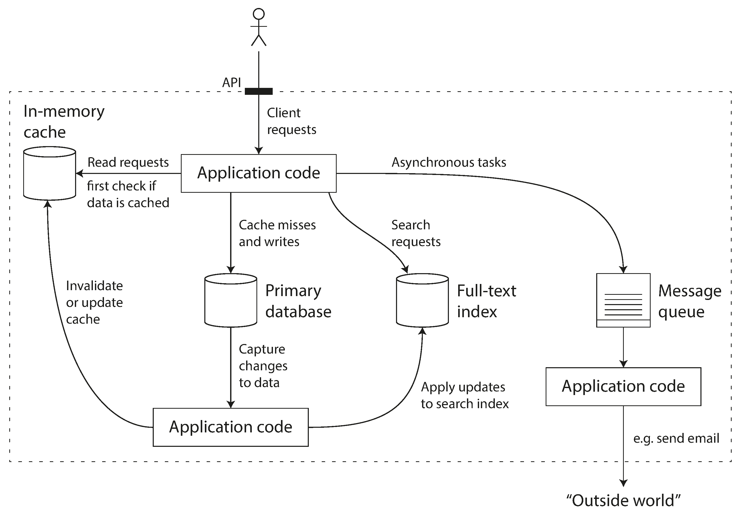3-Our team will work closely with the stakeholders to identify the various types of data that need to be stored and managed within the system, such as books, authors, publishers, and users. Than we will then create data models that describe the relationships between these different types of data. These models will be tested with the librarian and other stakeholders to ensure that they accurately reflect the needs of the library and its users. Our goal is to create data models that are efficient, flexible, and scalable, and that will enable the digital library and management system software application to manage large collections of books, documents, and other resources.

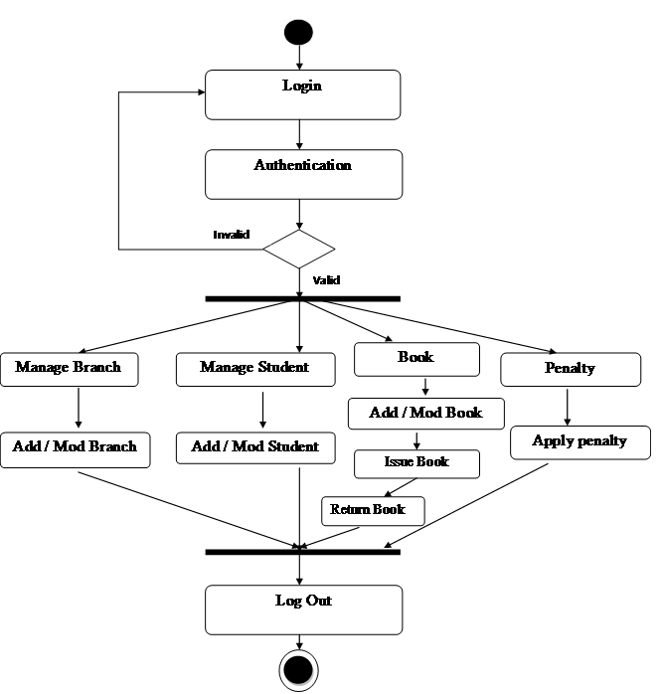5-Creation of activity diagrams: Activity diagrams are used to represent the flow of activities and tasks in the system. In our digital library and management system software application, activity diagrams describe processes such as borrowing and returning books, managing user accounts, and searching for resources.

6-Development of class diagrams: Class diagrams are used to describe the structure of the system and the relationships between the different types of objects in the system. In our digital library and management system software application, class diagrams are used to describe the different types of resources, users, and permissions in the system.

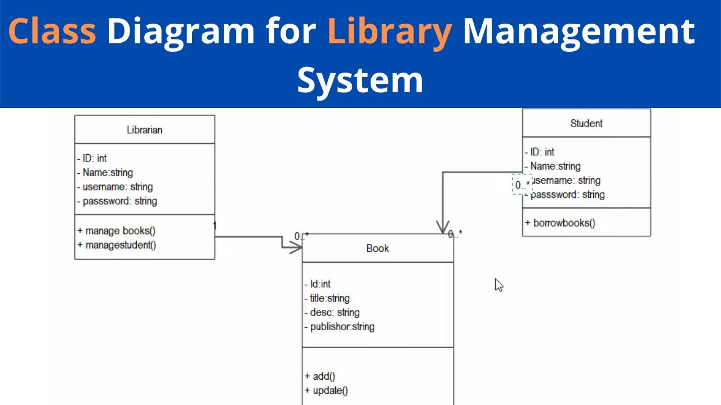

7-Creation of sequence diagrams: Sequence diagrams are used to describe the interactions between the different components of the system. In our digital library and management system software application, sequence diagrams are used to describe how users search for resources, how resources are borrowed and returned, and how the system interacts with external systems such as payment gateways and cataloging systems.

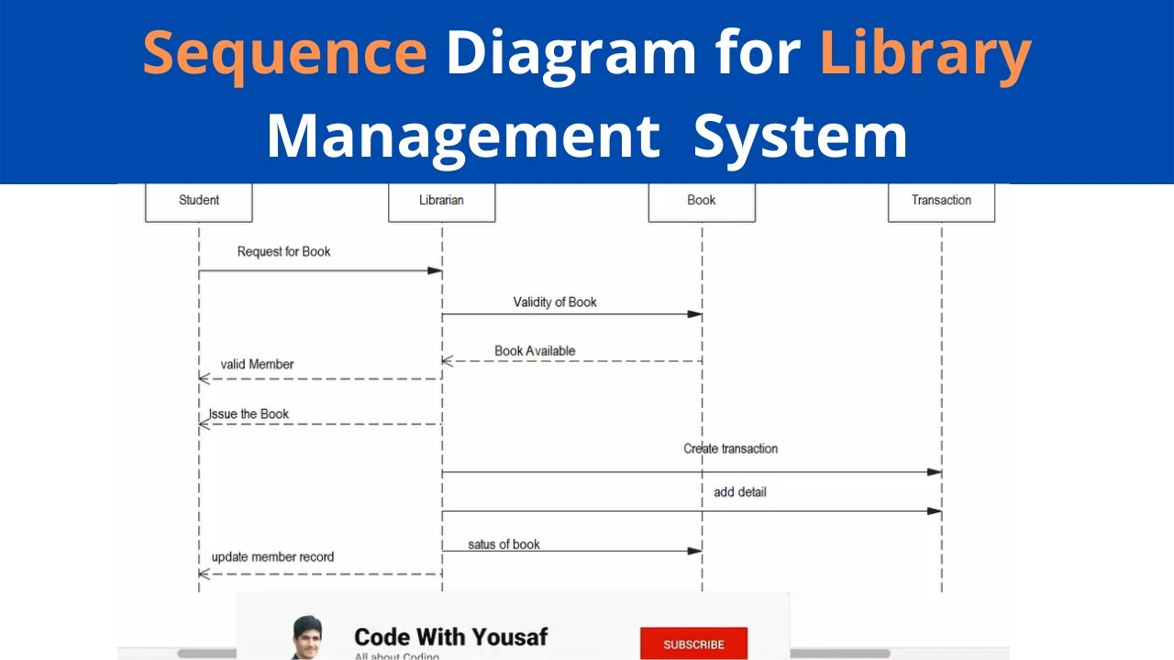

8- Development of state diagrams: State diagrams are used to describe the behavior of the system in response to different events and inputs. In our digital library and management system software application, state diagrams are used to describe the different states of resources, such as available, reserved, and borrowed.

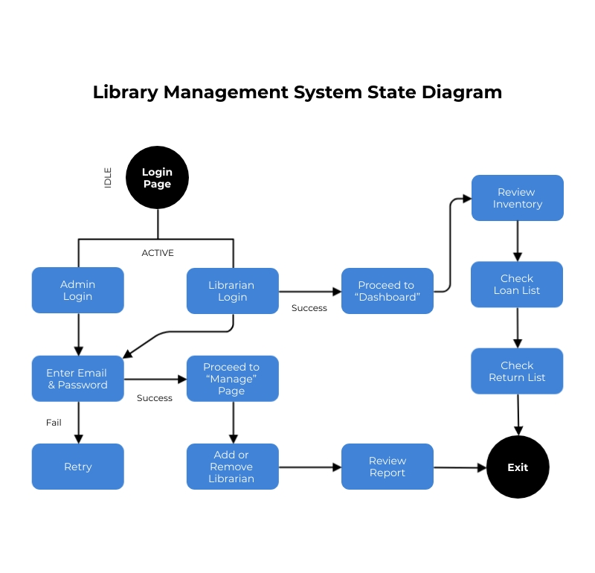

In conclusion, the software design and modeling phase is a critical step in the development of a digital library and management system software application. By analyzing the requirements, designing the user interface, creating data and architectural models, and developing activity, class, sequence, and state diagrams, we can ensure that the software application meets the needs of the library and its users, and that it is efficient, scalable, and easy to maintain. Following an agile development process has allowed us to work closely with the librarian and other stakeholders to gather feedback and make any necessary changes to the models, ensuring that the final software application will be a valuable resource for the library and its users.